Improving quality of dying and palliative care in care homes

Workshop handout pack

Liz Forbat & Aisha Macgregor

This handout accompanies the workshop at the ENRICH Conference,
Edinburgh, March 2024

Contents

What Are Palliative Care Needs Rounds? 1
Why use Needs Rounds? 2
Palliative Care Needs Rounds Checklist 4
Videos and resources 5
How to start 6
Needs Rounds Evidence Base 7
Example cases Error! Bookmark not defined.
Role description of the specialist palliative care clinician delivering Needs Rounds 8

Copyright Liz Forbat

What Are Palliative Care Needs Rounds?
Palliative Care Needs Rounds have three components:
- An hour-long triage meeting. This is run with a palliative care specialist (often a nurse from the local hospice), and care home staff (nurses, care assistant, facility managers and other staff). The meeting focuses on several residents who are at risk of dying without a plan in place; this is often residents with the most complex needs. Their psychosocial, spiritual, and physical needs are discussed in the Needs Round. A checklist¹ is used to guide the meeting, discussions and actions. The Needs Round includes education for care home staff, based on the residents discussed.
________________________________________________________________
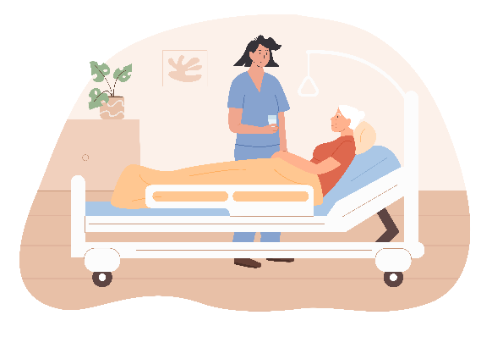
- Direct clinical work. At times it can be useful for the specialist palliative care clinician to meet residents, to assess their symptoms and help decide what the best next step might be. They will draw from their expertise in hospice care, and this can supplement any clinical assessments conducted by the care home staff or GP. This can lead to recommendations about deprescribing or accessing end of life medicines.
________________________________________________________________

- Multidisciplinary team meetings, or family meetings.
These meetings can be attended by relevant parties, such as: specialist palliative care clinician, resident, relatives, GP, and care home staff. The purpose is often focused on: future care planning, or sharing information and decision-making with the family.

Why use Needs Rounds?
The purpose of Needs Rounds approach is to help prepare for each resident’s last months and days of life. It can also provide a space for care home staff to learn from a specialist, as Needs Rounds includes education and learning, based around the residents being discussed.
Figure 1 shows the key elements of Needs Rounds. The Needs Rounds approach can:
- build care home staff confidence and help anticipatory planning for resident’s last months of life, deterioration, and death.
- help strengthen relationships between care homes and hospices. It can also help build trust between different organisations.
- provide protected time to collaborate and to increase high quality resident-centred care.
- ensure residents can die in their preferred place, by drawing on the different but complimentary skills that care home staff and hospice staff have.
- help families feel more confident in the care provided.
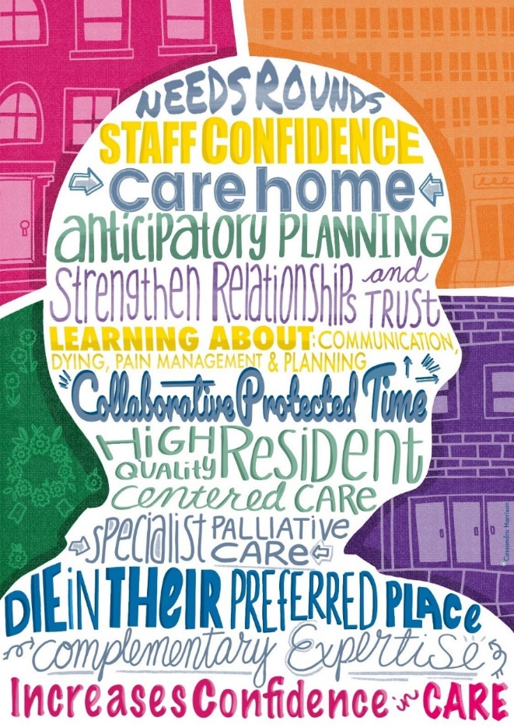
Figure 1: What Needs Rounds offer; © 2022 Cassandra Harrison Art. All rights reserved. Reproduced with permission

A recent implementation study of Needs Rounds in Scotland and England² sits alongside evidence from pilot studies and a large trial in Australia to map out the context, and changes that need to happen to improve outcomes which enable Needs Rounds to support people to live and die well in care homes.
Benefits are evidenced for the whole system, by providing care in the home to reduce demand on the acute system, enabling people to live and die well within care homes:
- residents (better quality of life and death),
- relatives (greater confidence in the quality of care being provided),
- care home staff (increased capacity to look after people using a palliative approach),
- specialist palliative care staff (closer working relationships with care homes, addressing unmet needs),
- GPs (drawing in specialist support alongside primary palliative care),
- acute services (reducing avoidable acute admissions).

Palliative Care Needs Rounds Checklist
Triggers to discuss resident at needs rounds
One or more of:
- You would not be surprised if the resident died in the next six months
- Physical or cognitive decline or exacerbation of symptoms in the last month
- No plans in place for last six months of life/no advance care plan
- Conflict within the family around treatment and care options
- Transferred to our facility for end of life care

Actions
- Medication review (e.g. change meds, anticipatory meds)?
- Organise surrogate decision maker?
- Develop an advance care plan?
- Organise a case conference?
- External referrals (e.g. pastoral care, dementia support services, wound care)?
- Refer to specialist palliative care?

2. New Referrals
- What are the resident’s diagnoses and co-morbidities?
- What are their palliative care needs (including physical, psychosocial and spiritual symptoms)?
- What are staff current concerns around treatment or goals of care?
- Who supports the resident outside the facility (eg family/friends)?
- Provide case-based education (eg recognising deterioration and dying, bowel management,
pain assessment, talking to GPs)

1. Reviews
- Have all actions been implemented?
- Have any new symptoms or concerns emerged?
- Give positive feedback on actions that the staff managed well
- Decide if the resident should be kept on the specialist palliative care list, for on-going review

Forbat, L,. et al. (2018) Improving specialist palliative care in residential care for older people: a checklist to guide practice. BMJ Supportive and Palliative Care. 8(3): 347-353.

Videos and resources
Printed resources and some brief videos: Palliative Care Needs Rounds resources - Calvary Health Care (calvarycare.org.au)

A needs round in action: https://vimeo.com/438800160/bc3a44cee9?ts=136000&share=copy

UK care home and hospice nurse talking about using Needs Rounds: Palliative Care Needs Rounds in the UK (youtube.com)

How we involved people with personal experience in the UK work on Needs Rounds: PPIE in palliative care research - YouTube

A manual and quick start guide to using Needs Rounds: https://www.calvarycare.org.au/wp-content/uploads/2020/08/Calvary-Palliative-Care-Needs-Rounds-Implementation-Manual.pdf

How to start
- Resources for using Needs Rounds are freely available to download and use.
- The checklist and implementation guides can be accessed via https://needsrounds.stir.ac.uk/
- ‘Quick start guides’ to enable specialist palliative care teams and care home staff to prepare to start using Needs Rounds.
- Workshops can be run for teams to demonstrate set-up and running of the model, address questions, and consider local context in adapting the approach.
- Briefing meetings can be requested for commissioners.
Want to know more?
Contact the team via Prof Liz Forbat: elizabeth.forbat1@stir.ac.uk

Needs Rounds Evidence Base

Needs Rounds:
- Decrease length of hospitalisations,
- Improving rates of residents dying in their preferred place,
- Enabling staff to normalise death and dying,
- Improves residents dying with dignity, compassion and comfort,
- Improves workforce confidence.

Key references
- Chapman MD, Johnston N, Lovell C, Forbat L, Liu WM. Avoiding costly hospitalisation at end of life: findings from a specialist palliative care pilot in residential care for older adults | BMJ Supportive & Palliative Care. BMJ Supportive & Pallative Care. 2018;8(1):102-9.

- Forbat, L,. Lui, W-M,. Koerner, J,. Lam, L,. Samara, J,. Chapman, M,. Johnson, N,. (2020) Reducing time in acute hospitals: a stepped wedge randomised control trial of a specialist palliative care intervention in residential care homes. Palliative Medicine. 34(5):571-579.

- Johnston N, Lovell C, Liu WM, Chapman MD, Forbat L. Normalising and planning for death in residential care: Findings from a qualitative focus group study of a specialist palliative care intervention. BMJ Supportive & Pallative Care. 2019;9(1).

- Koerner, J,. et al. (2021) Context and mechanisms that enable implementation of specialist palliative care Needs Rounds in care homes: Results from a qualitative interview study. BMC Palliat Care 20, 118 (2021).
- Liu WM, Koerner J, Lam L, Johnston N, Samara J, Chapman M, et al. Improved quality of death and dying in care homes: a palliative care stepped wedge randomised control trial. Journal of the American Geriatric Society. 2019.

- Samara, J, Liu, W-M,. Kroon, W., Harvie, B., Hingeley, R., Johnston, N. Telehealth Palliative Care Needs Rounds During a Pandemic. Journal for Nurse Practitioners. March 2021

Role description of the specialist palliative care clinician delivering Needs Rounds
The Needs Rounds palliative care practitioner will function within their clinical scope of practice to deliver quality client centred care for residents in collaborating nursing homes.
The palliative care clinician will:
- Provide a leadership role within the specialist palliative care service and collaborating nursing homes for Needs Rounds
- Actively foster knowledge and provision of palliative care within the collaborating care homes
- Facilitate Needs Rounds, according to the guidelines provided by the research team
- Support care home staff to improve their delivery of end of life care
- Provide case-based education during Needs Rounds
- Facilitate, or co-facilitate, case conferences for residents, as required
- Provide clinical assessment, diagnosis, therapeutic management and evaluation of care home residents, as indicated by discussions within Needs Rounds
- In collaboration with the residents, the care home and relevant members of the resident’s family, develop a patient centred care plan to manage identified needs.
- Maintain appropriate clinical records, using the specialist palliative care service’s standard operating procedures

Essential
- Registered health practitioner
- Minimum 3 years post graduate experience in palliative care.
- Demonstrated advanced clinical knowledge, skills, experience and practice in the clinical assessment, diagnosis, investigation, treatment and referral as well as follow up care of patients requiring specialist palliative care.
- Understanding of multiple morbidities of care home population
- Demonstrated high level communication, liaison, interpersonal and negotiation skills and an ability to form relationships with internal and external stakeholders.
- Proven ability to prioritise and undertake timely comprehensive assessments of patients using evidence-based practice.
- Proven ability to work within a risk management framework to ensure a high standard of safe clinical practice.

